Abstract— The purpose of the lab is to explore the functionality of the memory cell which is called “sequential circuit”. On this lab, student gain more experiment with RS latch, D latch, D flip flop, and JK flipflop.

CmpE 124 Lab #5: Latches and Flip-flops
Hoang Le, SID:012679771, CmpE 124 Spring 124, Lab Section #3

INTRODUCTION

Logic circuits are known as combination and sequential. While combination depend on its current inputs, sequential circuit is not only use the current input but also use previous output. For this experiment, students are using LogicWork to build the circuit and to compare the output on logic work with given truth tables and decide whether the truth tables are correct or not

Design methodology

Parts List

- 3 SN74HC00 (Nor gate 02)
- 1 SN74HC02 (Nand gate 00)
- 2 SN74HC74 (D flipflop)
- 2 SN74HC109 (Jk flipflop)

Truth Tables
Table 1:SR latch with nor gate
S | R | Q’ | Qn’
0 | 0 | q | qn
0 | 1 | 0 | 1
1 | 0 | 1 | 0
1 | 1 | Not allowed | Not allowed

Table 2: SR latch
S’ | R’ | q | qn
0 | 0 | q | qn
0 | 1 | 0 | 1
1 | 0 | 1 | 0
1 | 1 | Not allowed | Not allowed

Table 3: Controlled-SR latch
s |  | r | c | q | Z(qn)
0 |  | 0 | 1 | q | qn
0 |  | 1 | 1 | 0 | 1
1 |  | 0 | 1 | 1 | 0
1 |  | 1 | 1 | Not allowed | Not allowed
x |  | X | 0 | q | qn

Table 4: Controlled-D latch
D | c | q | qn
0 | 1 | 0 | 1
1 | 1 | 1 | 0
X | 0 | q | qn

Table 5: D-type flip-flop
Pre | clr | d | clk | Q+ | Qn+
0 | 0 | 0 | rising | 0 | 1
0 | 0 | 0 | Rising | 0 | 1
0 | 0 | 1 | Rising | 1 | 0
0 | 0 | 1 | Rising | 1 | 0
1 | 0 | X | X | 1 | 0
0 | 1 | x | X | 0 | 1

Table 6 : JK-type Flip-Flop
pre | clr | j | K’ | clk | Q+ | Qn+
0 | 0 | 0 | 0 | Rising | Q | qn
0 | 0 | 0 | 1 | Rising | 0 | 1
0 | 0 | 1 | 0 | Rising | 1 | 0
0 | 0 | 1 | 1 | Rising | toggle | Toggle
1 | 0 | X | X | X | 1 | 0
0 | 1 | x | X | x | 0 | 1

Table 7 : JK- flipflop
pre | clr | T | clk | Q+ | Qn+
0 | 0 | 0 | rising | q | qn
0 | 0 | 1 | Rising | toggle | toggle
1 | 0 | X | X | 1 | 0
0 | 1 | X | X | 0 | 1

Karnaugh Maps

Insert Karnaugh maps here if applicable.

Original and Derived Equations

Equation 1: SR latch: Q+ = S + R’Q
Equation 2: D Latch: Q+ = D
Equation 3: D Flipflop: Q+ = D
Equation 4: JK Flipflop: Q+ =JQ’+K’Q

Schematics
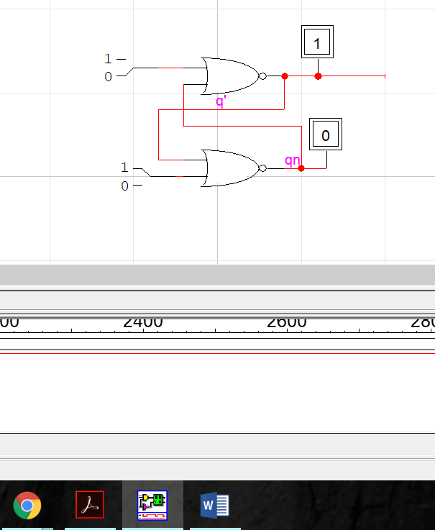
Figure 1: SR-lactches with input is 0 and output is memory.

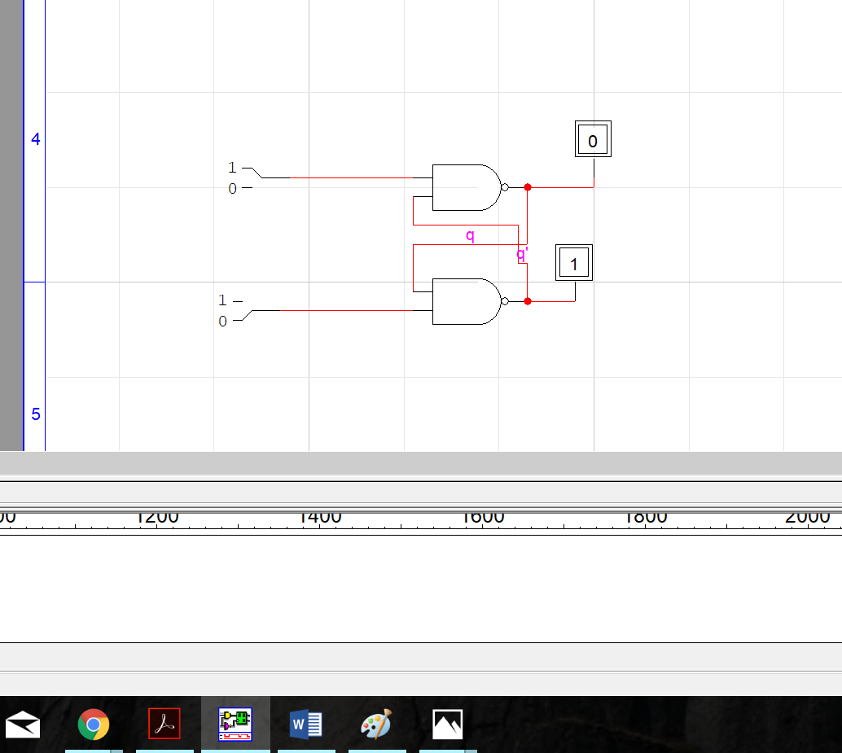
Figure 2: Nand Gate SR-latches with input S(1) and R(0) and the output is q(1)

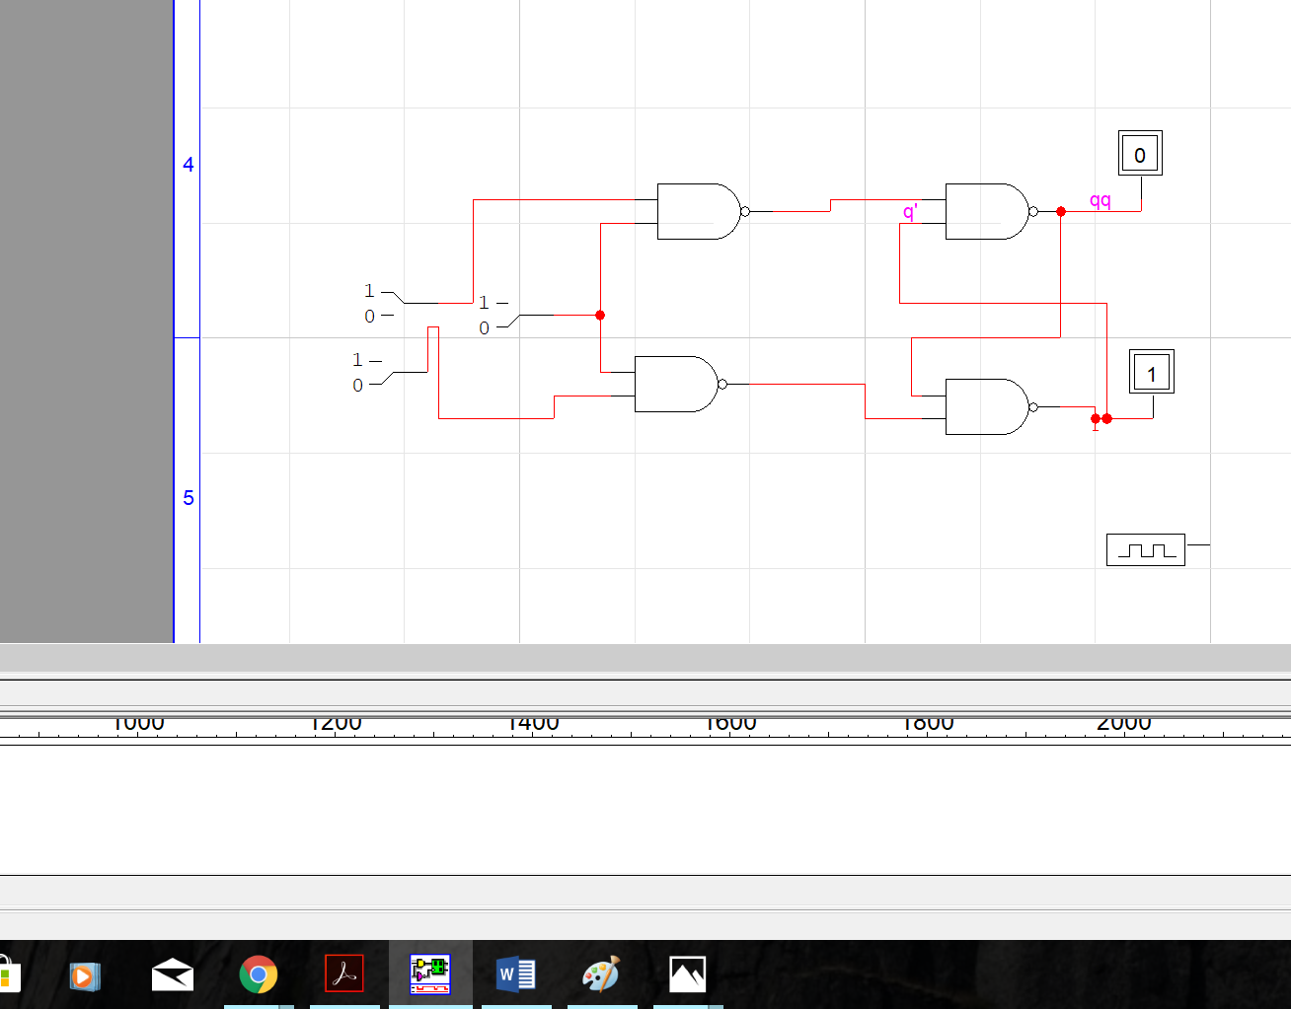

Figure 3: controlled SR latches

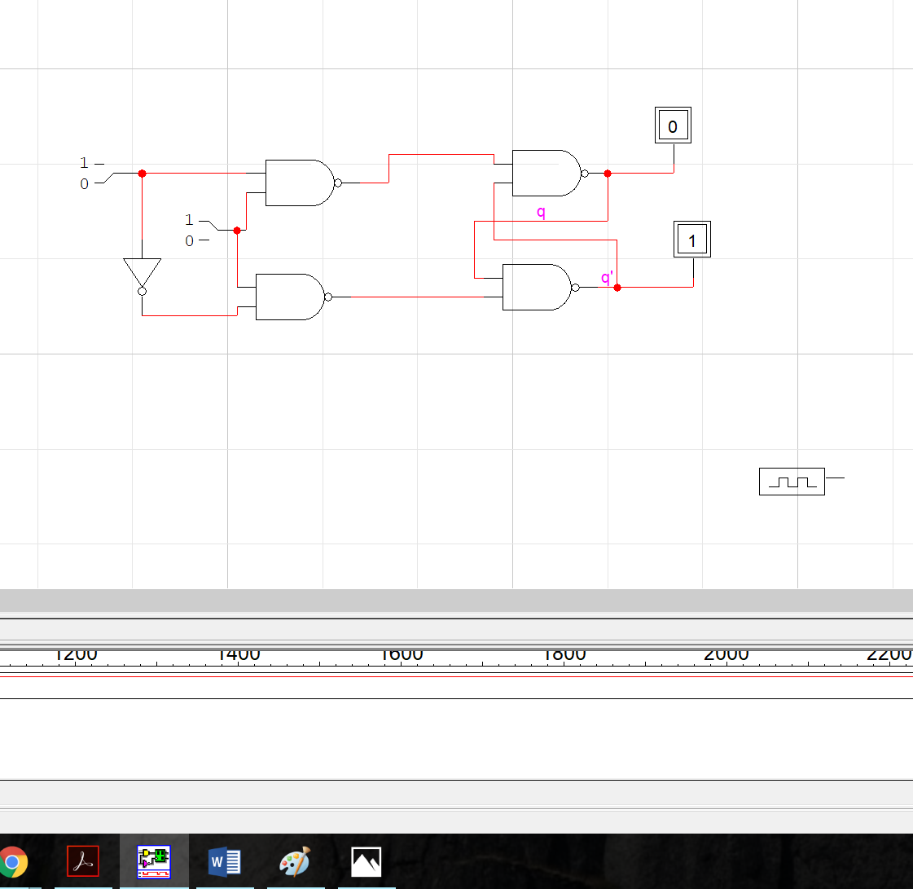
Figure 4: Controlled D-latches
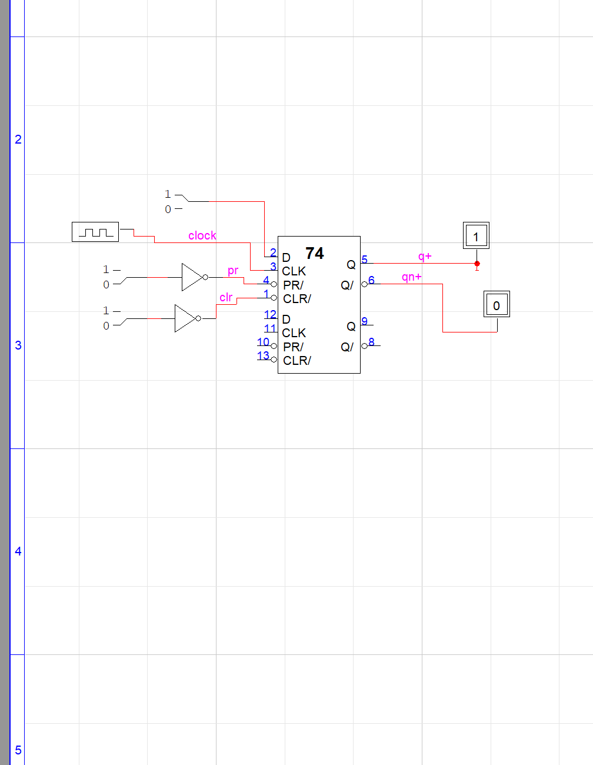
Figure 5: D-type flip-flop

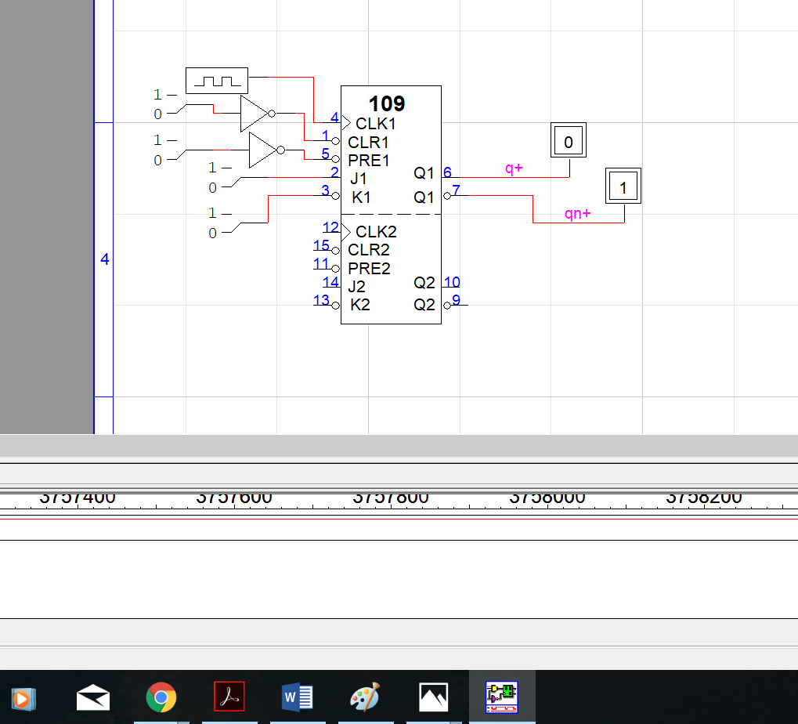
Figure 6: JK flip flops

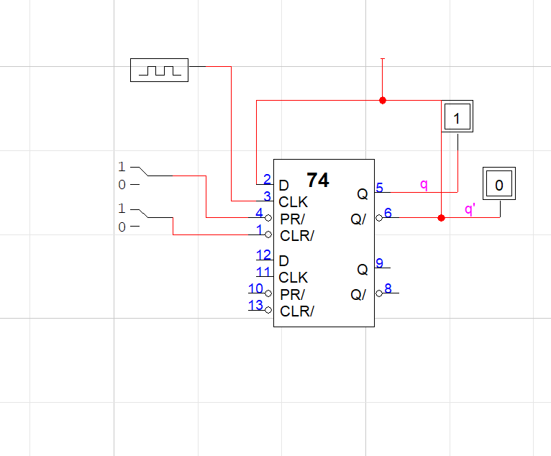
Figure 7: One clock cycle d type flip flop

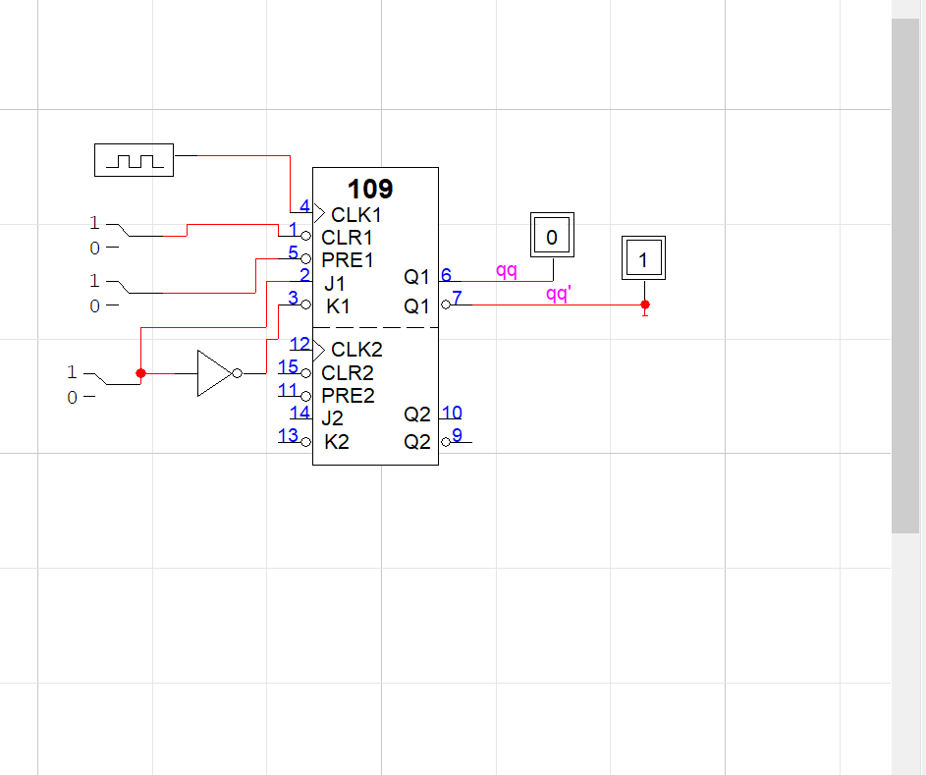
Figure 8: J-k flipflop

testing procedures
Build the circuit on logicworks and compare the output from the logic works with the truth table in the lab manual.

testing results

For the figure 1: SR latches with or gate
The output in the logic works is different with the truth table in the lab manual. This mean the truth table is not true.
Q’ = QN

For the figure 2: SR latches with nand gate
The output in the logic works is as same as with the truth table in the lab manual.

For the figure 3 : SR latches with control signal
The output in the logic works is as same as with the truth table in the lab manual.

For the figure 4: Controlled D-latch
The output in the logic works is the same with the output in the truth table of the lab manual.

For the figure 5 : D-type flip lop
The truth table in the lab manual is different with the output in the logic works. This means the truth table in the lab manual is wrong.

For the figure 6: J-k-Flipflop
The output of the logic works is different with the truth table in the lab manual.

For the figure 7: One cycle clock D- flip flop
The output of the logic works is different with the truth table in the lab manual.

For the figure 8 : J-k flip flop with the opposite J-k input
The output of the logic works is the same with the ttruth table in the lab manual.

Conclusion

Throughout this lab, students gain more experience as well as understanding about RS latch , RS latch with control, D flipflop and JK flipflop. The tricky part I n this lab is the JK flipflop. While the D flipflop getting the output Q+ = D input , the JK flipflop basically is the connection of D flipflop with and 08 and 32 register. Jk flipflop depend on its value of J and K to give the output. After all, the experiment is finished successful and clear.

appendices and references

Khalil A.Estell , Mikko Bayabo, Harmander Sihra, Haluk Ozemek. CMPE124 Digital Design I, Course Manual. Khalil A.Estell.

 

